Nipun Wadhwa

Dr. Dana Milstein

Writ 150 - 11:00 AM

November 2nd, 2018

**Communities Within a Community**

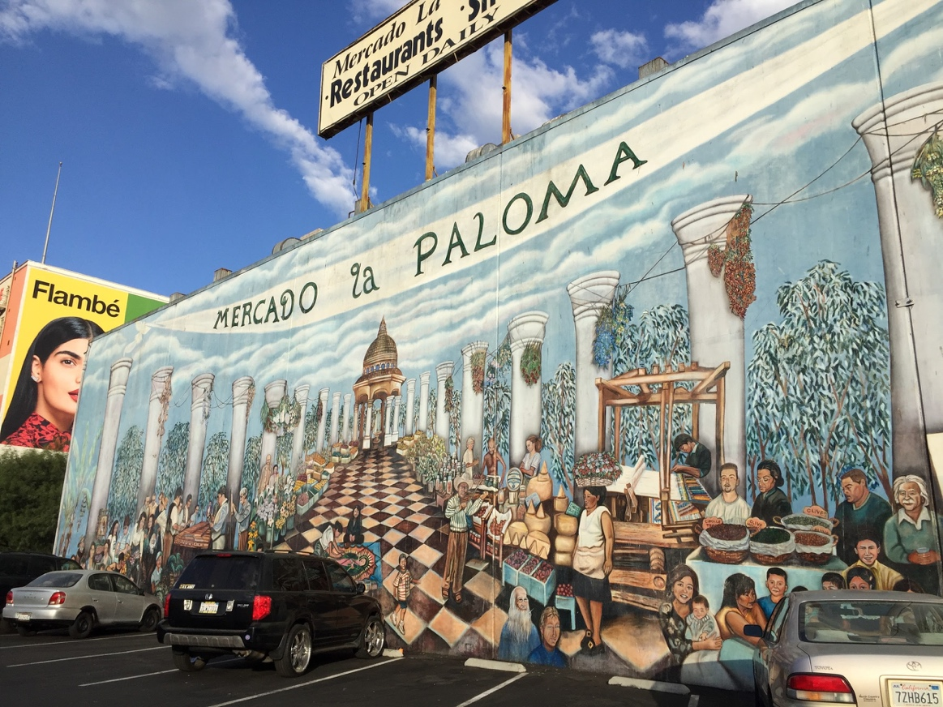At almost 50% Latino, 25% white, 16% Asian, 7% black, and 3% other, “University Park is one of the most ethnically diverse neighborhoods in Los Angeles.” With many murals in the area, one significant to study is the “Mercado La Paloma”. U-Park’s Mercado promotes versatile, community culture, with regards to, gentrification, food, and demographics, while defining the neighborhood as an adaptable society that has been shaped into a diverse district.

Figure Mercado La Paloma Mural located on S Grand Ave. Photo taken by Elizabeth Winnicki

Many factors contribute to the gentrification that led to University Park’s development. The novel USC Village is a controversial addition, as it causes financial and physical change for neighboring houses and schools in positive and negative ways. USC gentrifying the neighborhood is not the only adaptation that must be dealt with; food has a significant impact on the families and students in U-Park. For example, there are many shops around USC, central to varying cultures. Students have the option to cook or dine in at shops that cater everything from good ole’ American burgers to modern Indian “khana” and Greek food. Another food option open to USC students and the greater U-Park community are the three on-campus cafeterias. Although uncommon, families can dine with students by paying for the buffet the cafeteria is serving that day. In terms of the food adapting to U-Park, there are modern Indian restaurants, featuring a diverse staff, instead of traditional ones. The diverse dining options that cater to U-Park’s global community correlate to the community’s racial demographics. This society is represented through diverse ethnic groups that have been forced to adapt to the evolving surroundings shown in the mural. Compared to the racial and financial demographics of USC, the nearby elementary schools have much higher proportions of Hispanic population and lower class families. The mural reflects this difference in demographics, showcasing the many diverse faces that define University Park - the mural’s target audience can see themselves within the mural’s subject matter. The mural features a target audience that is being spoken to and is seen on the mural itself; specifically, Mercado shows that the Hispanic families of U-Park value being together with their community through food and children despite the fact they sacrifice their neighborhood to the gentrification of USC.

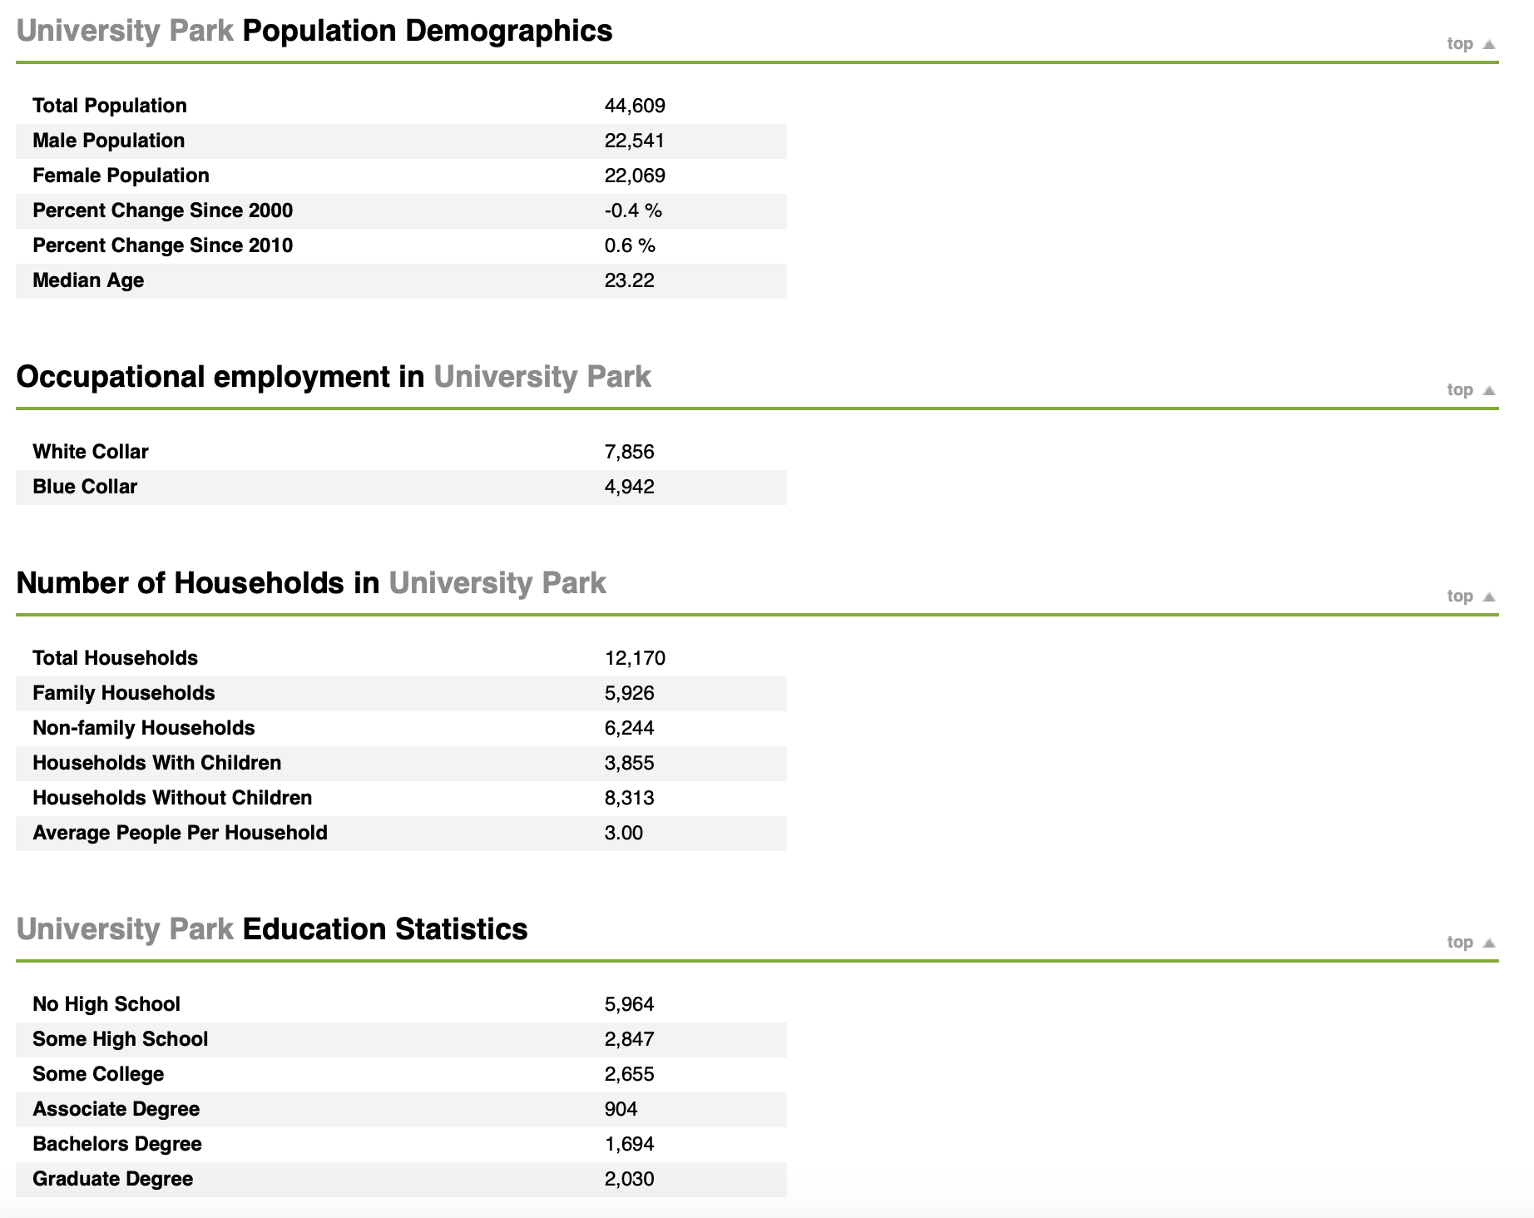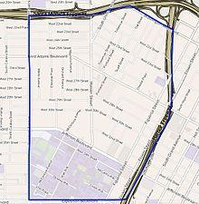

*Fig. 2: Demographics of University Park Fig. 3: Map of University Park*

Recently, the university built USC Village, connecting the pre-existing campus to a former shopping center. The USC Village includes a variety of establishments meant to cater to every possible student need. Additionally, the village provides supplementary housing options for USC freshmen and sophomores. Specifically, the beautifully constructed village boasts the largest gym in LA, a full-sized Target, a Trader Joe’s, and a vast set of restaurants. Thanks to the many new businesses, students gain a privilege of choice - the freedom to live in whatever way they so choose. However, the new development’s vast benefits overshadow the burdens it places on the surrounding community; the cost of USC Village is far more than just financial. The cost incorporates factors of replacement and moral injustice, replacing previous shops that have been around for decades with novel boutiques owned by USC, to gain profits and publicity for the university.

Thanks to the village’s innovation, these businesses provide students with multiple dining options. While this seems beneficial for the students, it generates more competition for the prior vendors, like the food trucks that have been in the area for decades. Through personal experience, I have noticed that they attract much more of the younger consumers, such as students from elementary schools around the area, rather than the college students. Generally speaking, non-monetary costs of the Village include the eviction of previous shop owners and newfound competition for surrounding vendors.

USC bought out the previous establishment to construct a “village” of high end shops for dining, shopping, and personal services. These shops make it easier for students to stay within their comfort zone, never leaving the USC bubble. This also decreases students’ exposure to the greater Los Angeles community, keeping them from one of college’s main purposes: exploring a new environment and gaining new experiences. Thanks to the village, rather than going down the road to buy groceries and witnessing the homelessness problem in LA, students now remain protected by the campus, relying on TJ’s and Target.



Figure Parshanna Wilson working at the clinic holding a pair of glasses

However, not all aspects of the village are detrimental to the residents. For Parshanna Wilson the village opened up an opportunity to pursue an ophthalmology career. Wilson is a “single mom raising two teenage sons while working and studying full-time” (Mackovich). She works at the USC Village before heading to USC’s Health and Sciences campus to attend class. No stranger to U-Park and its surrounding area, Wilson was “born and raised in the South Los Angeles area, [she] worked in the biopharmaceutical industry for years, then took a job at USC Village” (Mackovich). Furthermore, she speaks highly of the new Village; for a resident of the surrounding area, this is a rare case. She “never get[s] bored at USC Village” and appreciates the opportunities it provides (Wilson). Many workers in the USC Village dining halls are also thankful for the opportunities the village grants. They speak highly of the jobs that the Village opened up for them. However, there are many downsides to the Village and the bubble it creates around USC students.

I was in a Lyft and I didn’t know where I was because I couldn’t see a USC building; however, I was one street away from an area I use every day. The bubble created by USC leaves its students lacking exposure to the real world. Once graduated, it will be difficult students to adjust to any living situation where shops are not directly under their residence or within a mile distance. USC students are so trapped that they don’t realize that the village was a step in the process of gentrification, harming the area’s previous residents.

Gentrification also impacts the residential areas near USC’s campus; specifically, Greek organizations contribute to the gentrification of local houses. Roughly 25% of USC’s student body is affiliated with a fraternity or sorority. Though gentrification can be defined as “the process of renovating and improving a house or district so that it conforms to middle-class taste,” it is also exemplified by students taking over houses and expanding their living options further and further every year. Houses provide students an increased sense of freedom; this freedom allows more parties to be thrown, disturbing non-USC community residents. Many are deterred from buying a house near campus because of the frequent parties throughout the surrounding area. As a result, home prices are driven down, enabling students easier access to buy or rent a house. In turn, real estate companies see lower profits, emphasizing the negative impacts of new renovations.

This past weekend, my friends and I searched for a place to live for the upcoming school year, and we toured a house slightly west of campus. We learned how it was designed to house multiple college students and had a big backyard specifically for the purpose of throwing parties and parking cars. After visiting more and more houses, we saw patterns in the design of housing. We concluded that real estate companies adapted to the college environment and, at the cost of the local community, renovated houses to cater to college student’s needs. Greek life contributes to the overall gentrification of the homes around USC, making the community of U-Park less and less comfortable for its former residents.

Elementary schools around campus are primarily comprised of minorities. I tutor at two local elementary schools: Norwood Elementary and Birdielee Elementary. Norwood Elementary and is located northeast of campus; it is an underdeveloped and underfunded school with a primarily Hispanic population. The children mainly speak Spanish to each other, the administration communicates with each other in Spanish, and the teachers use Spanish when students struggle to understand lessons. This shows the disparity between the demographics of USC’s immediate community and the demographics of the greater area. The other school, Birdielee Elementary, is west of campus and is more developed and does not suffer the same lack of funding. However, its demographics are the same. When a student asked me to explain a topic I taught in class, I could not understand her because she asked in Spanish. The teacher then assisted the student, talking to her in Spanish and further explaining the lesson. I felt as if USC did not prepare me for this situation. I was dumbfounded because I could not communicate in a language spoken by 38% of my city and nearly 50% of my residing area. Unlike me, a student trapped in the USC bubble, the teacher accommodated the needs of her community, specifically adapting to the needs of her students. Moreover, I can now say that elementary schools offer more exposure to the real-world than USC.

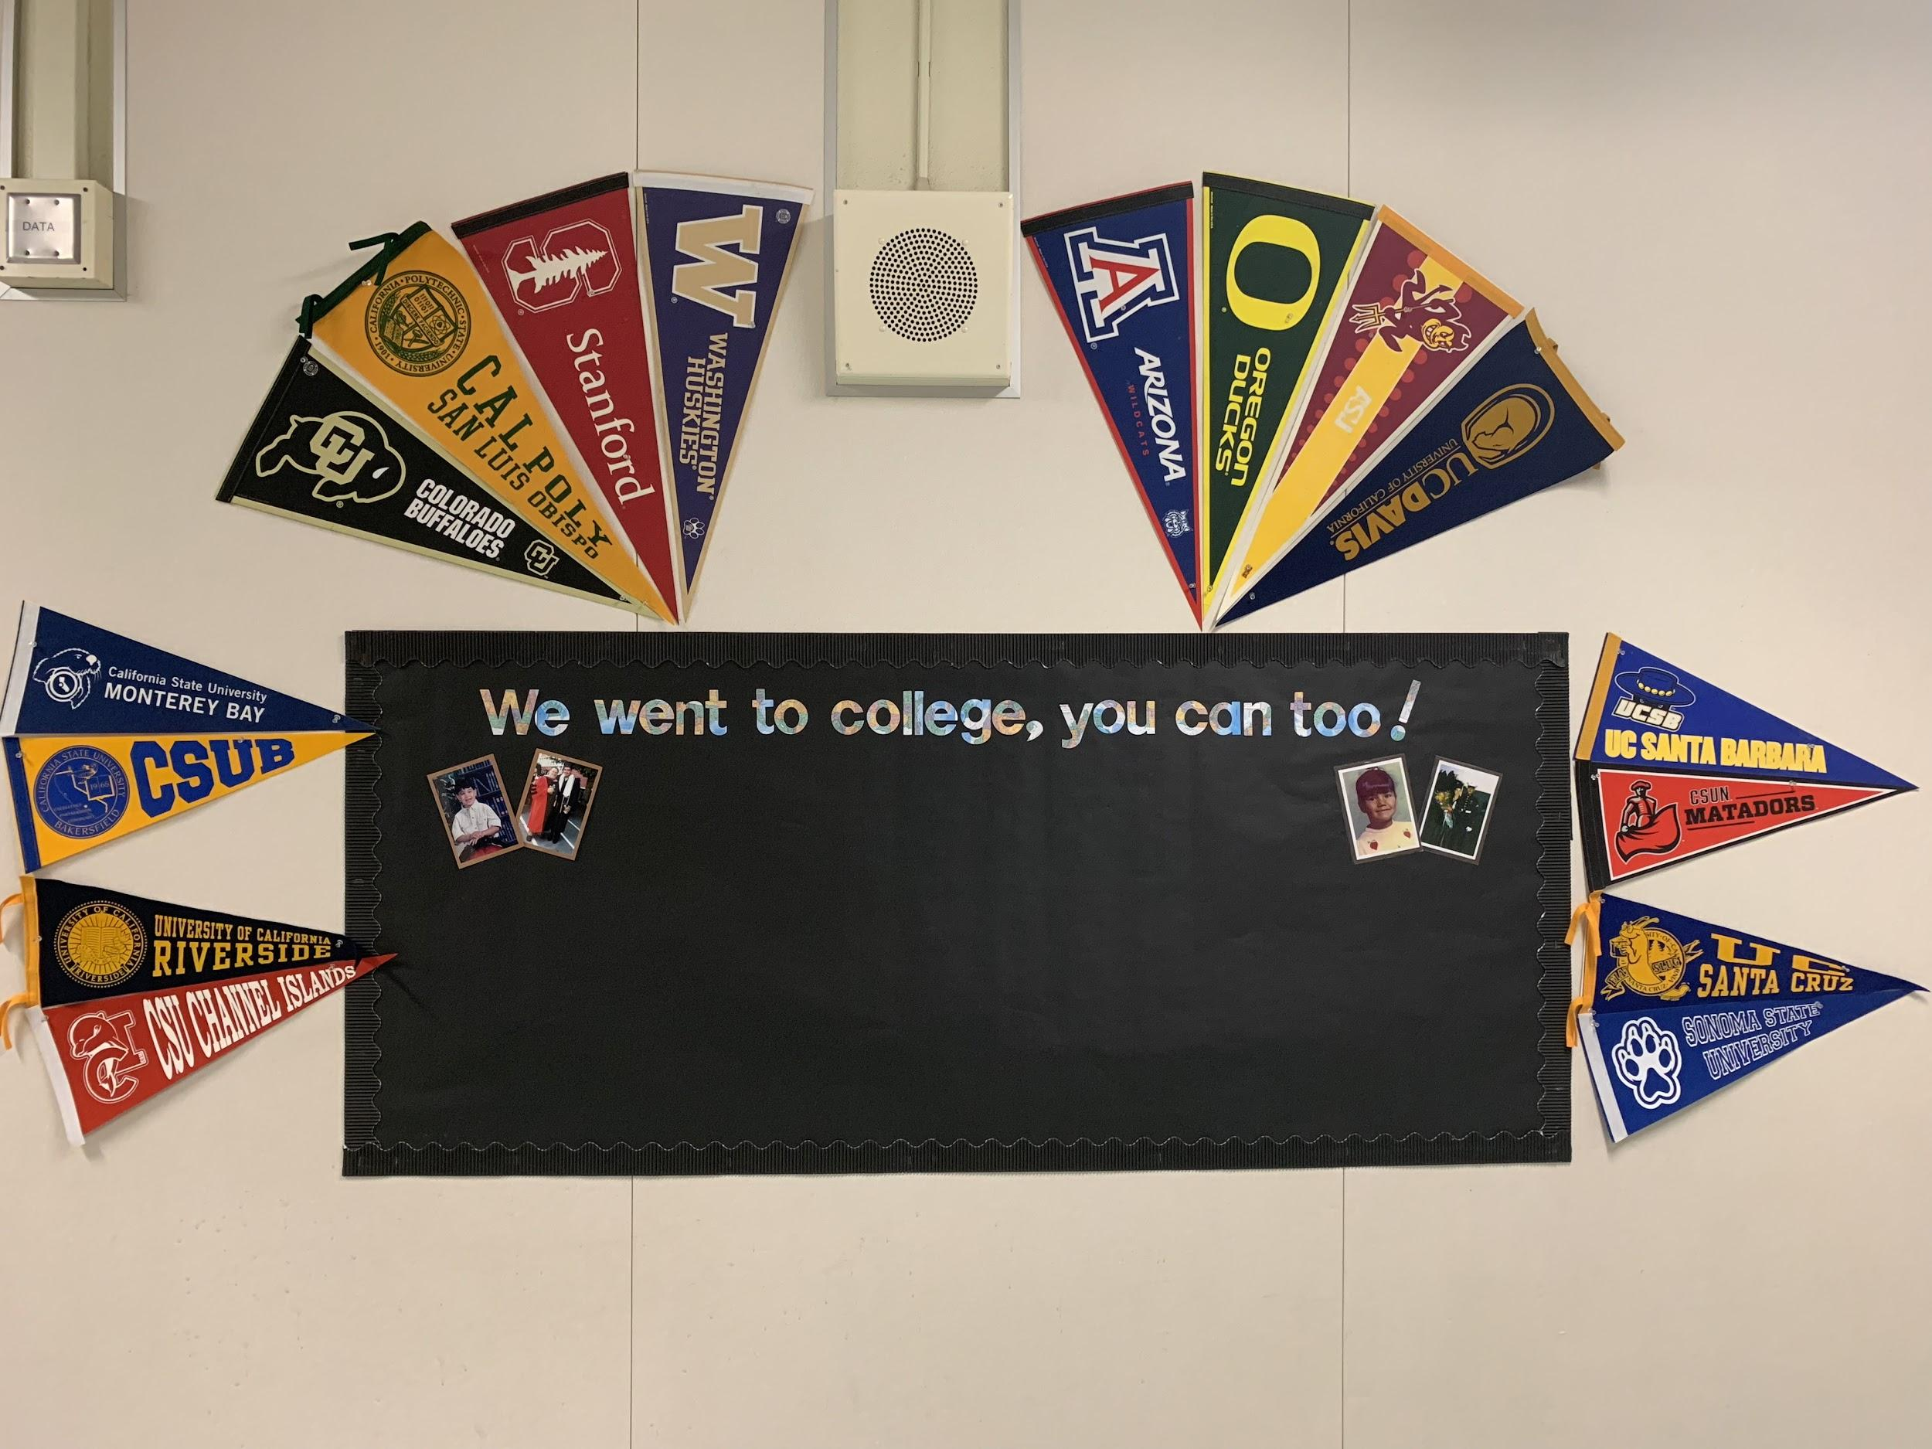

Figure 3 Board of college motivation at Norwood Elementary

Norwood Elementary started a project to encourage students to attend college. Challenging the community norms of entering the workforce immediately after graduation, Norwood wants to encourage their students to pursue a collegiate path. To do this, they bring in USC students and put up a board showcasing Norwood alumni and faculty who attended college. Growing up in a similar town, many of my classmates either joined the workforce, enlisted in the military, or did nothing after high school. I was the only student in my graduating class to leave the state for college; most of my friends went to the local university or state college. Coming to a school like USC where students do not believe the high school stories I tell them, I can relate to Norwood Elementary in a very personal way. Later on, to receive a more personal perspective on teacher experience, I spoke to several teachers who have been around their respective schools for over a decade.

I interviewed Lily Garcia, a teacher in her 18th year at Norwood. She runs the school’s after-school program and explained the great changes occurring throughout her time at Norwood. During her first few years, kids were more disciplined and it was easy to get them to settle down. Today, she says, they talk back much more often. This reflects our generation and parallels the student body at USC. We will argue with our professors to get points back and speak up for rights violated by the school. For example, when Ben Shapiro was on campus, there were many protests, exemplifying the new generation’s willingness to challenge authority, unafraid to speak out regardless of our age. This mindset of students and children contrasts the children depicted in the Mercado Mural. The students in the mural are disciplined and do not have a voice to speak out. Education gives children a voice in today’s society and this remains true within the schools around U-Park.

Furthermore, to compare perspectives, I interviewed a teacher from Birdielee Elementary school. Mrs. Polard Miralda spoke highly of her school and I expected that. When I go to that school, I see that, unlike Norwood, discipline is not a problem between the students and faculty. Mrs. Miralda said that she disciplines her students and does not tolerate kids who are disrespectful or talk back. Discipline is correlated to school performance because that is all that school has ever been, a measure of discipline rather than intelligence. “There are many systems in place when a student misbehaves” speaks Miralda. The teacher further mentioned that “over time, [she has] seen children come and go. They are pretty much the same; however, the environment around the school drastically changes. There is great influence from USC in positive and negative ways.” She spoke about positive effects such as the inspiration that her students receive when a USC student speaks to them. Students at Birdielee admire the USC tutors that come on campus and teach lessons. “It gives the students a figure to look up to,” spoke Miralda. However, due to the expansion of USC’s campus, many of the students’ parents have lost jobs or relocated. This means that their children must relocate to different schools and are likely to face financial difficulties at home. Moreover, the demographics of the school are similar to that of U-Park. Although Birdielee and Norwood are completely different in terms of discipline and performance, both schools have a heavy concentration of minorities and Spanish can be heard between faculty and the students. USC is a stark contrast from the two elementary schools; the campus is mostly white and primarily English speaking. Though these racial and language demographics are the same in surrounding areas, the schools’ performances greatly differ.

The greater Los Angeles area is full of culture. With a population of four million, there is a diverse variety of food. There are many ethnic restaurants, food trucks, and grocery options. From halal restaurants to taco trucks, the area around USC has a variety of food, catering to every possible cultural need or dietary restriction.

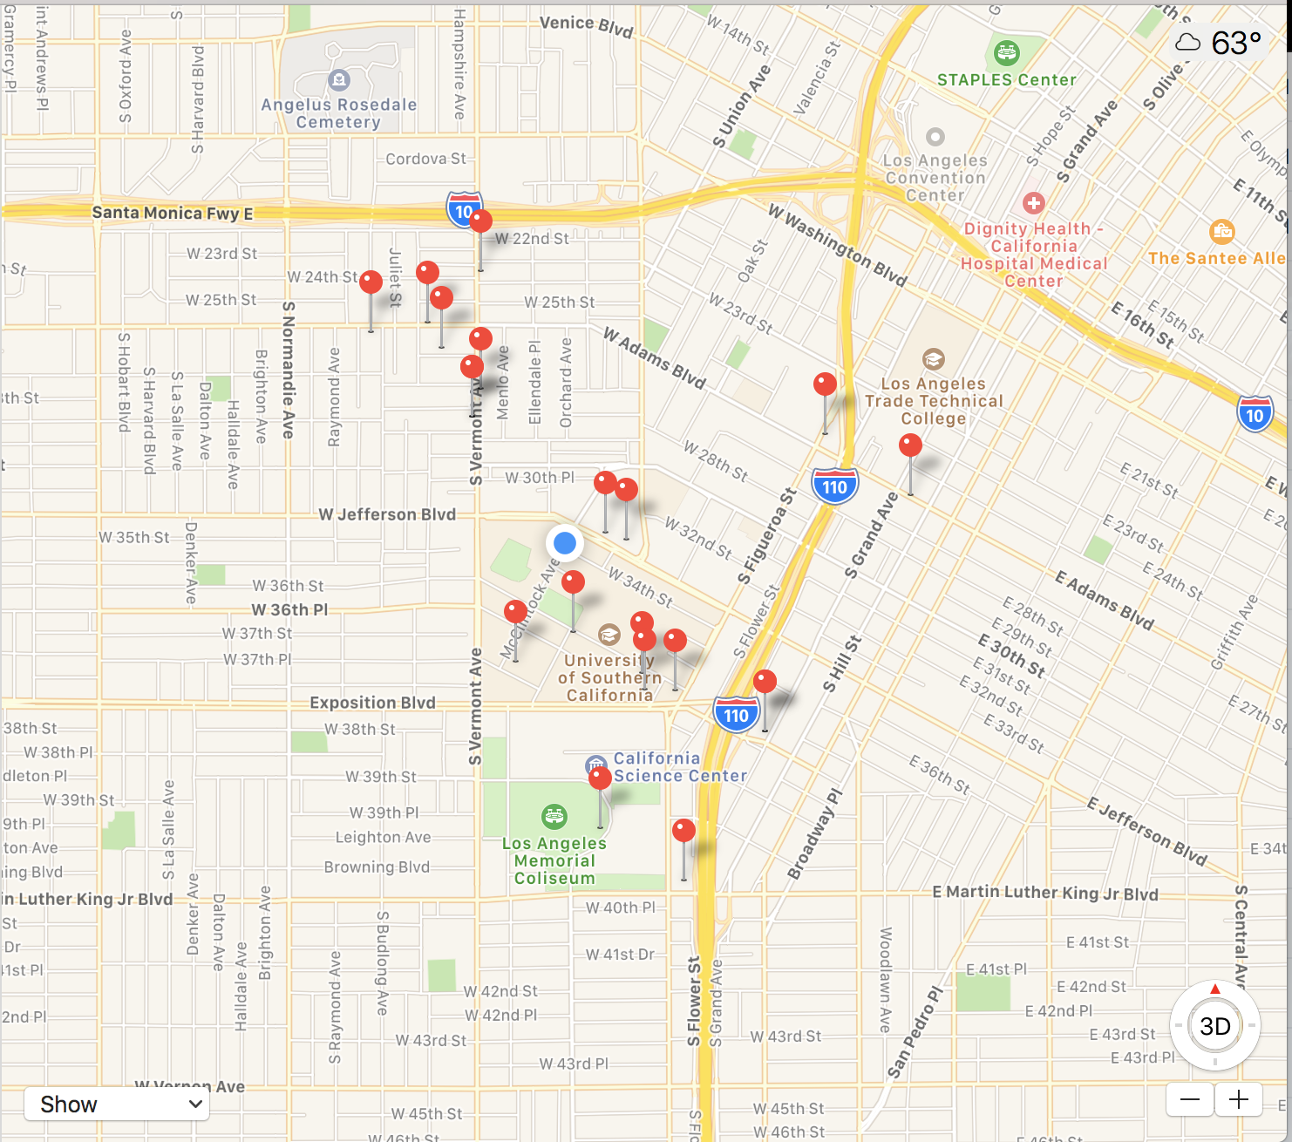

Figure 4 Food choices on Apple Maps

With so many food options, there is never a monotonous meal schedule. Food is one of the most important factors within a community. As seen in the Mercado mural, food brings the community together. On campus, people can choose between the many different Starbucks, meeting and chatting with old friends or possible recruiters; they can even enjoy just sitting by themselves. However, as shown in the Mercado Mural, food is all about the coming together of friends and family. In the bottom right corner of the mural, these gatherings show the community has a sense of family, just like the USC Trojan family. This is a similarity that we share with the community. Sometimes, the community will come together, joining the students in events. One program, for example, is Share-A-Meal, where a food truck will go from the USC campus to deliver food to those in need, all throughout the surrounding community. Students will eat with the community and chat before moving onto the next area. Programs like these are vital to preserve a positive relationship between the communities of U-Park and USC. Giving back to the community and interacting with its residents is a necessary for a community like ours to thrive.

Since USC attracts students from all over the world, it makes sense for the surrounding area to reflect the same level of diversity and multiculturalism. As a result, there are many diverse restaurants. In a casual walk through campus to the student-friendly off campus apartments, it is easy to encounter hundreds of different ethnic backgrounds, classes, and genders. It is imperative to identify these identities and factors because of the importance of diversity to Los Angeles, the city U-Park and USC reside in. Los Angeles is home to a vast number of diverse communities, all of which must be equally represented by politicians and the media. Racial identity and treatment of that identity “play in the experiences of Mexican Americans” (Ortiz). UCLA Alumni, Vilma Ortiz further explores the treatment of the Mexican-Americans who arrived in the United States a century ago, attempting to explain their position in America today. For similar reasons, it is crucial to learn more about how race is handled and treated in the surrounding U-Park community. While “some consider Mexican Americans similar to European Americans of a century ago that arrived in the United States with modest backgrounds but were eventually able to participate fully in society,” others believe different (Ortiz). Moreover, the Mercado reflects the diversity of ethnicities in the community. There are a significant number of people in the mural that are Hispanic or African American.

In terms of financial factors that contribute to today’s food culture, college students provide a great opportunity for foreign entrepreneurs to profit. Restaurant owners can capitalize on collegiate communities and the diversity they offer. Since college exposes them to more diverse cultures, students often want to try different international foods. College offers incomparable opportunities to learn about diversity, both on campus and off, through both food and the general community.

Since not all students eat from food trucks and restaurants in the area, many students visit the dining hall on a daily basis. For the greater U-Park community, the USC cafeteria is an exotic and exciting place to eat, but many students see it as a last result. Though the public is allowed to dine at the USC dining halls, they rarely do so. Families don’t do this because they are either unaware or they see USC as a somewhere they don’t belong. This may be sad to many individuals, because no one should feel out of place in their own community.

To receive a more personal account, I interviewed a dining hall worker, Julian Saadeh. He said he doesn’t eat at the dining halls because he feels like an outsider to the USC community. Mr. Saadeh feels his status as a worker prevents him from feeling comfortable enough to dine with students. Luckily for the workers, they can eat for free during their lunch breaks. Additionally, they have their own room to eat in along with the other workers. USC’s incorporation of these rooms is interesting, seeming as if if USC knew that the workers would not feel comfortable dining alongside the students. In contrast, the Mercado Mural represents the community around U-Park dining all together, no matter who is making, selling, or eating the food. Ideally, while eating together, age, class, and race are not even considered. Unfortunately, on USC’s campus, they are.

U-Park’s families feel very similarly to the dining hall workers. Unlike the students, families think the dining hall seems appetizing, providing the opportunity to enjoy a buffet style meal with plenty of options for all dietary restrictions. However, families don't come to eat because they would not be comfortable coming to a campus where they feel as if they don't belong. Mr. Saadeh stated that “I might see a family once in a blue moon. The only time it is expected is during family events and even then the families come with the students. So, it is just like a family of Trojans are walking in, just like a group of students walking in that are friends - a family of Trojans.” Similarly, the Mercado Mural exhibits the value of dining together as a family. It depicts a family of children, a family of Mexican-Americans, a family of seniors, and a family of marketers. The cafeteria is an opportunity to gather for the students and families in the area, but that is not what occurs.

In comparison to a traditional Indian restaurant, a modern Indian restaurant can be identified by its the diversity in staff, the music, and the aesthetics of the food. A visit to any local Indian restaurant shows lots of diversity in staff and management. Downtown’s Badmaash has workers of almost all ethnic backgrounds, from white to Indian. My friend and I were the only Indian customers. This shows that the restaurant must cater to not only Indians, but the rest of LA. The ambiance was also modern and adjusted to American culture. For example, soft coffee shop music was playing rather than Indian tunes. Similarly, there was dim lighting at night, which is considered scandalous in some parts of India and almost non-existent in Indian restaurants. The artwork was of flowers and American scenery rather than Indian idols, Indian landscapes, and Indian monuments. On the other hand, a local Indian restaurant in U-Park, Himalayan House, shows the opposite. There was no diversity in the staff, bright lighting, Indian music playing, and artwork of the cultural impact of India. This is important to compare because the difference shows the direction in which adaptation is heading. In many years to come, U-Park Indian restaurants will be more like downtown Indian restaurants, like Badmaash. Areas are constantly adapting and becoming more modern; this is a simple example of the American melting pot. Cultures from all over the world come together to meet in America and adapt to societal norms.

To receive a more personal response, I interviewed the owner of Manas. Mr. Deep Singh said “I get customers from all diverse ethnic groups. So I must employ diverse ethnic groups in order for the customer to feel comfortable in my restaurant. For example, if a white person walked into a restaurant with all Indian employees, they wouldn't feel as comfortable as if they walked into a restaurant with Indian and whites working.” Culture is forced to adapt to its surroundings and environment - the American melting pot.

As that can be seen in the Mercado Mural, the demographics of the schools and restaurants in U-Park are similar. The mural focuses on culture and community coming together through food, specifically, multicultural food. From Armando’s food truck to Indian restaurants, U-Park has always adapted and will continue to adapt to the diversity of the ethnicity it offers. The mural shows Hispanic families coming together with food to eat, buy, and sell. A scene like this can be seen on USC campus every Wednesday - the farmer’s market. Food vendors sell a multitude of eatery from chicken waffles to Hawaiian dishes. Students come together to buy and eat while the vendors sell. Similar to the concept of families of U-Park eating in the dining halls, families residing in the area are not seen on Wednesday’s at the market. They can too also enjoy the USC campus while eating together; this is something totally allowed, but simply does not occur.

Education further plays a role in the communication between the adults and the children. The passing of wisdom from elders to the younger generation is in essence similar to schooling. The concept of wisdom associated to elders has been around for a long time. This notion can be seen represented in many murals across Los Angeles; however, specifically in the Mercado, one can see elders teaching the young of the community in the bottom left. Skills ranging from music to sewing are being taught to the younger generation of the community. This aspect in the mural is vital because the artist wanted to show that the older generation realizes that the younger generation is the future of the community and they must put their efforts in to pass down their wisdom well. The mural demonstrates the importance of education and food in the community of University Park, exemplifying the demographic factors in USC’s surrounding neighborhood.

The mural’s target audience is crucial to discuss; many people see this mural every day. Its location within U-Park is a traffic heavy area, maximizing its exposure to the public. For example, in the picture, there are cars parked in front of the mural. Parking lots in Los Angeles are rarely deserted. The fact that the artist chose the wall of a parking lot to paint the mural is a choice of marketing. The artist clearly wanted to reach a wide range of audiences and groups that park and use that lot every day. His target is the local community. Reaching out to the locals and reminding them every day of the mural and its meaning was a intended effect that will be long lasting. The artist’s target audience consists of all the communities represented in the mural and those who are not. For the people represented, the artist wants to remind them every day of where they come from. For the people not represented, the artist wants to remind them every day of the people that they are living with and who resided in the U-Park area first. These racial demographics reach out to both USC and U-Park.

USC and U-Park’s demographics differ in many ways. In one, the community is 30% white and 28% international, in the other, the population is 48% Latino and 26% white. Without stating the other 26% that makes up U-Park, it is restless to say that “University Park is one of the most ethnically diverse neighborhoods in Los Angeles”. The Hispanic population at USC is three times lower than that of U-Park. This is crucial to learn for USC students in order to realize the community were are going to school in. With heavy Hispanic influence around the area, students are exposed to nothing more than a local Mexican bar, Banditos, and maybe the occasional Mexican food truck, Armando’s. However, there is much more entailed within the area of U-Park, such as the key demographic factors that have shaped the cultural moment of my neighborhood. All of these factors define my neighborhood, making it important to identify where I have come to study and what community I have entered for my four years of college.

I now see that the Mercado Mural, after a close study, has promoted long-term community culture, lasting through adaptations with factors such as gentrification, food, and demographics, shaping USC’s neighborhood into the diverse area that it is today. I have also realized the racial and social communities that are within the U-Park community. Throughout the research, there is much to explore that U-Park offers if only a USC student would take a step out of the USC bubble.

Works Cited

Gregor Aisch, Larry Buchanan, Amanda Cox, and Kevin Quealy. (2017, January 18). Economic

diversity and student outcomes at U.S.C. Retrieved from

<https://www.nytimes.com/interactive/projects/college-mobility/university-of-southern->

california

Mackovich, Ron. “Single Mom Keeps Her Eye on an Ophthalmology Career.” *USC News*, 19

Nov. 2018, news.usc.edu/151736/single-mom-keeps-her-eye-on-an-ophthalmology-caree

Ortiz, Vilma. “Racial Identity and Racial Treatment of Mexican Americans.” [US National](https://www.nlm.nih.gov/)

[Library of Medicine](https://www.nlm.nih.gov/) [National Institutes of Health](https://www.nih.gov/), 20 Nov. 2018,

<https://www.ncbi.nlm.nih.gov/pmc/articles/PMC3846170/>

University of Southern California. (n.d.). Retrieved from https://about.usc.edu/facts/

Zhang, Z. (2018, May 21). Unnamed Taco Stand [Unnamed Taco Stand]. Retrieved from

<https://www.yelp.com/biz_photos/unnamed-taco-stand-los->

angeles?select=oxGDT8hIrd345KZzN-urIw